Prashant BCT

[Email address]

Abstract

This document describes the pre-requisite, installation and initialization of TIBCO EBX tool.

TIBCO EBX SetUP GUIDE

Installation Guide

Contents

1 Supported Configurations 2

2 Required Downloads 2

3 Installation Steps 2

4 EBX Initialization on First Launch 7

4.1 Welcome Screen. 7

4.2 Validating the license agreement 7

4.3 Configuring the repository 8

4.4 Defining the default user for the EBX access. 8

4.5 Validating the information entered. 9

4.6 EBX Login Screen 9

5 TIBCO EBX Add-on Setup 10

5.1 Packaging Third Parties 10

# Supported Configurations

* Java Runtime Environment: JRE 8, 11 or 17.
* Any Servlet/JSP container that complies with Servlet 3.0 (inclusive) up to 5.0 (exclusive) for example, Tomcat 7.0 (inclusive) up to 10.0 (exclusive).
* PostgreSQL 10 or higher.

# Required Downloads

* Download the EBX software and EBX-add-ons from the TIBCO e-Delivery site.
* Download the apache tomcat 9.x from the tomcat site.
* RDBMS database.

# Installation Steps

This are the steps we need to follow to setup the EBX instance

1. Create the home folder (ebxHome) and server (ebxServer) folder for the EBX.

In this document we are using the following name and paths for folder.

Name and path can be anything no need to have same name and path.

* $EBX_HOME 🡪 ebxHome 🡪 C:\Softwares\EBX_Instance\ebxHome
* $CATALINA_HOME 🡪 ebxServer 🡪 C:\Softwares\EBX_Instance\ebxServer

From now on to refer this path we will use this variable names $EBX_HOME and $CATALINA_HOME.

**Folder Structure**

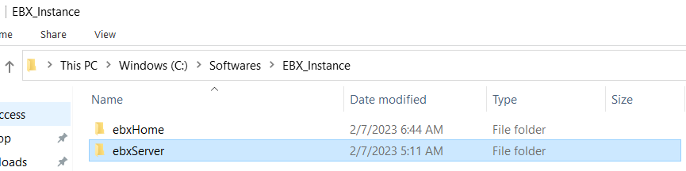

**ebxServer Folder**

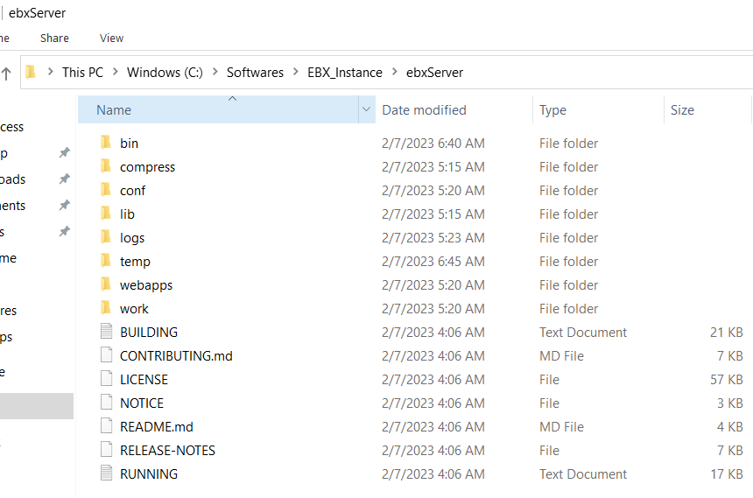

**ebxHome**

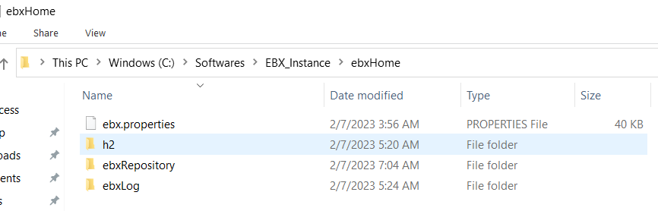

For setup we need only ebx.properties file other folder will be auto created when we initialize the EBX repository.

1. Copy from EBX CD the ebx.software/files/ebx.properties file to $EBX_HOME.

Update the ebx.properties file to connect to database if you are not using the default database which is h2, which we are using in this document.

For example, if you want to configure the Microsoft SQL Server you can uncomment the lines shown in below screenshot configure it properly and save the file.

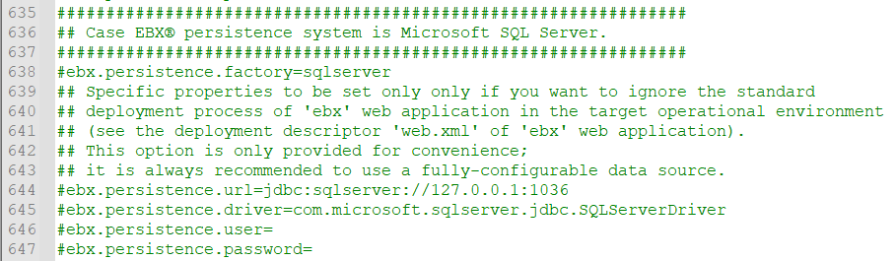

1. Update $CATALINA_HOME/conf/server.xml file by adding the following line to the <Host> element:

* <Context path="/ebx" crossContext="true" docBase="ebx.war"/>

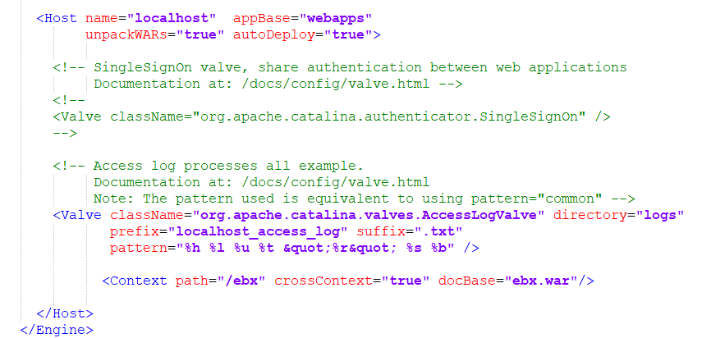

1. Modify the $CATALINA_HOME/conf/catalina.properties file by adding the following lines to the tomcat.util.scan.DefaultJarScanner.jarsToSkip property:

* ebx.jar,\
* ebx-addons.jar,\
* ebx-lz4.jar,\

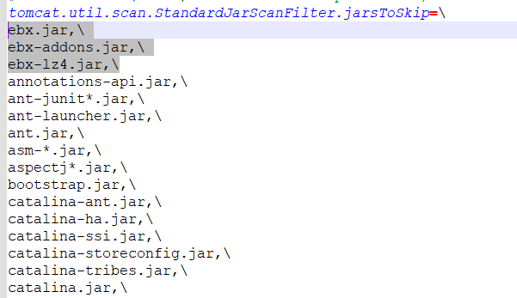

1. Set the environment variables by creating a setenv.bat file either into $CATALINA_HOME\bin or $CATALINA_BASE\bin. This file will hold, at least, the following lines

* set "EBX_HOME=..\..\ebxHome"
* set "EBX_OPTS=-Debx.home=%EBX_HOME% -Debx.properties=%EBX_HOME%\ebx.properties"
* set "JAVA_OPTS=%EBX_OPTS% %JAVA_OPTS%"
* set "CLASSPATH=..\compress\ebx-lz4.jar;%CLASSPATH%"

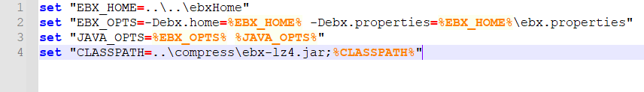

The paths mentioned here are relative path (w.r.t the location where setenv.bat is placed). We an use the fully defined path here also.

1. EBX and third parties’ deployment. Copy third-party libraries from the EBX CD to $CATALINA_HOME /lib/folder. List of Jars to deploy

* ebx.software/lib/javax.mail-1.5.6.jar,
* ebx.software/lib/h2-2.1.212.jar (if we are using H2 database, deploy proper driver jar as per database used),
* ebx.software/lib/xml-apis-1.4.01.jar,
* ebx.software/lib/ebx.jar

1. Deploy the Data compression library in the folder $CATALINA_BASE/compress. Copy following jar in this folder.

* ebx.software/lib/ebx-lz4.jar

1. Deploying the EBX web application. Copy from the EBX CD the war files in ebx.software/webapps /wars-packaging to the $CATALINA_HOME/webapps/ folder.

* $CATALINA_HOME/webapps/ebx.war: Initialization servlet for EBX applications.
* $CATALINA_HOME/webapps/ebx-root-1.0.war: Provides a common default module for data models.
* $CATALINA_HOME/webapps/ebx-manager.war: Master Data Management web application.
* $CATALINA_HOME/webapps/ebx-dataservices.war: Data Services web application.
* $CATALINA_HOME/webapps/ebx-dma.war: Data Model Assistant web application.
* $CATALINA_HOME/webapps/ebx-ui.war: User Interface web application.

1. EBX Application Start.

* After Tomcat launch, run EBX web application by entering the following URL in the browser: [http://localhost:<port](http://localhost:%3cport) number configured in server.xml>/ebx/

In our example: http://localhost:9080/ebx/

* At first launch, EBX Wizard helps to configure the default properties of the initial repository.

# EBX Initialization on First Launch

At first launch EBX configuration assistant guide will help in initializing the EBX instance. This are the steps to be followed while setting up EBX.

## Welcome Screen.

Click on the Start Configuration

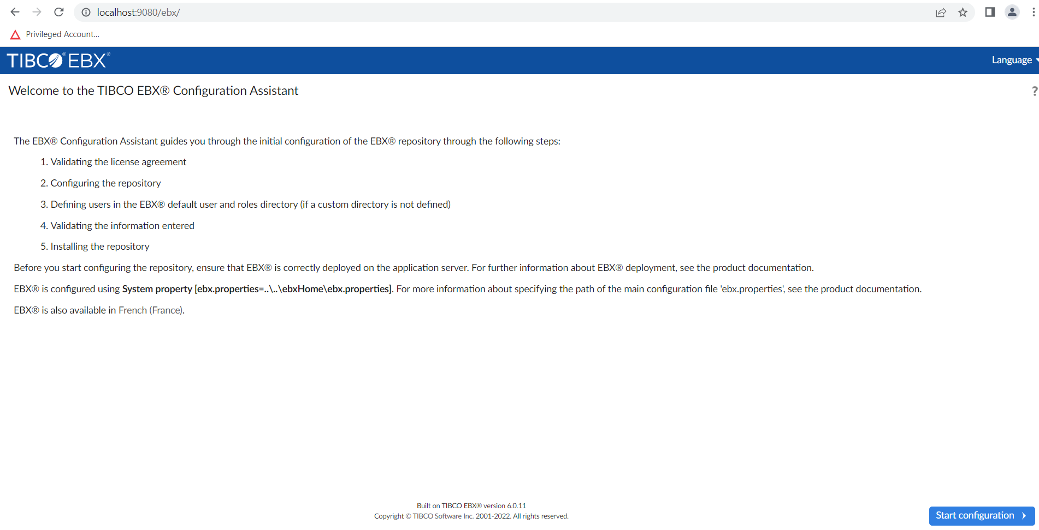

## Validating the license agreement

Click on I agree.

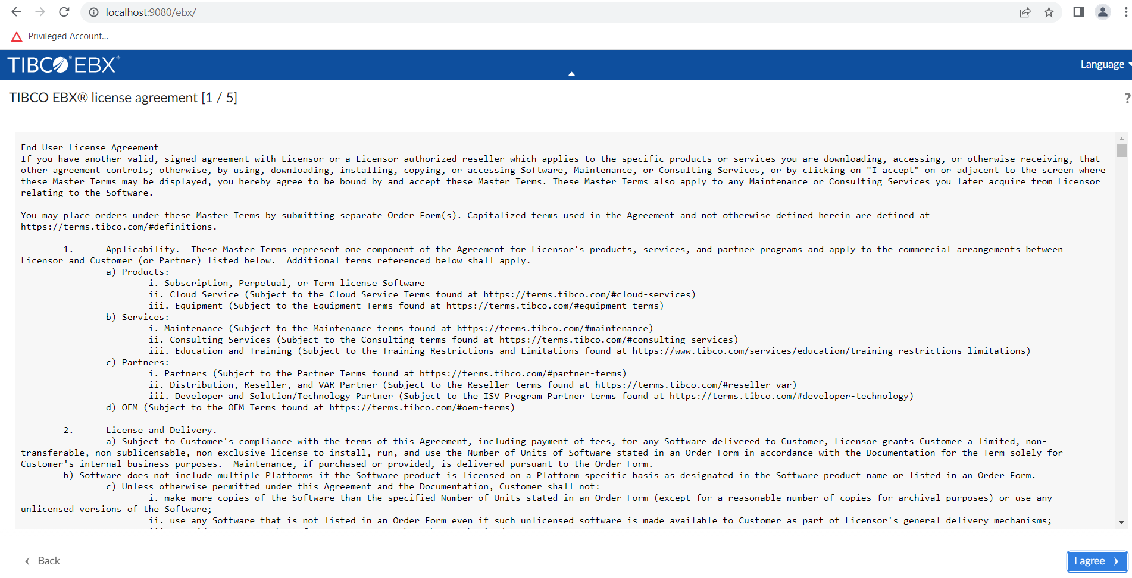

## Configuring the repository

Generate the Repository ID and give the Repository label (name describing the use of EBX instance).

* Repository ID: Must uniquely identify the repository
* Repository Label: Defines a user-friendly label that indicates the purpose and context of the repository.

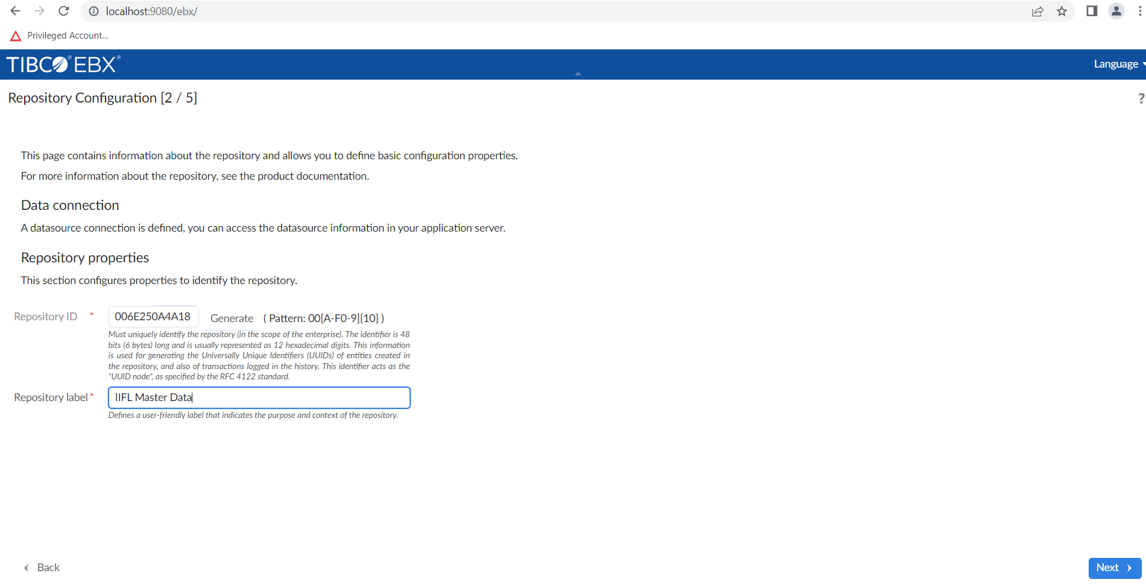

## Defining the default user for the EBX access.

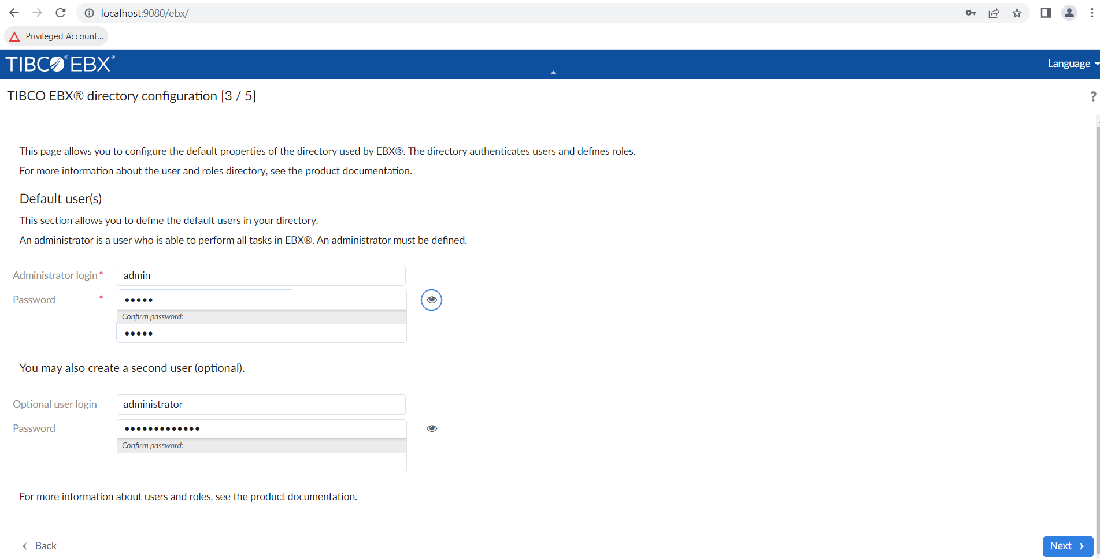

## Validating the information entered.

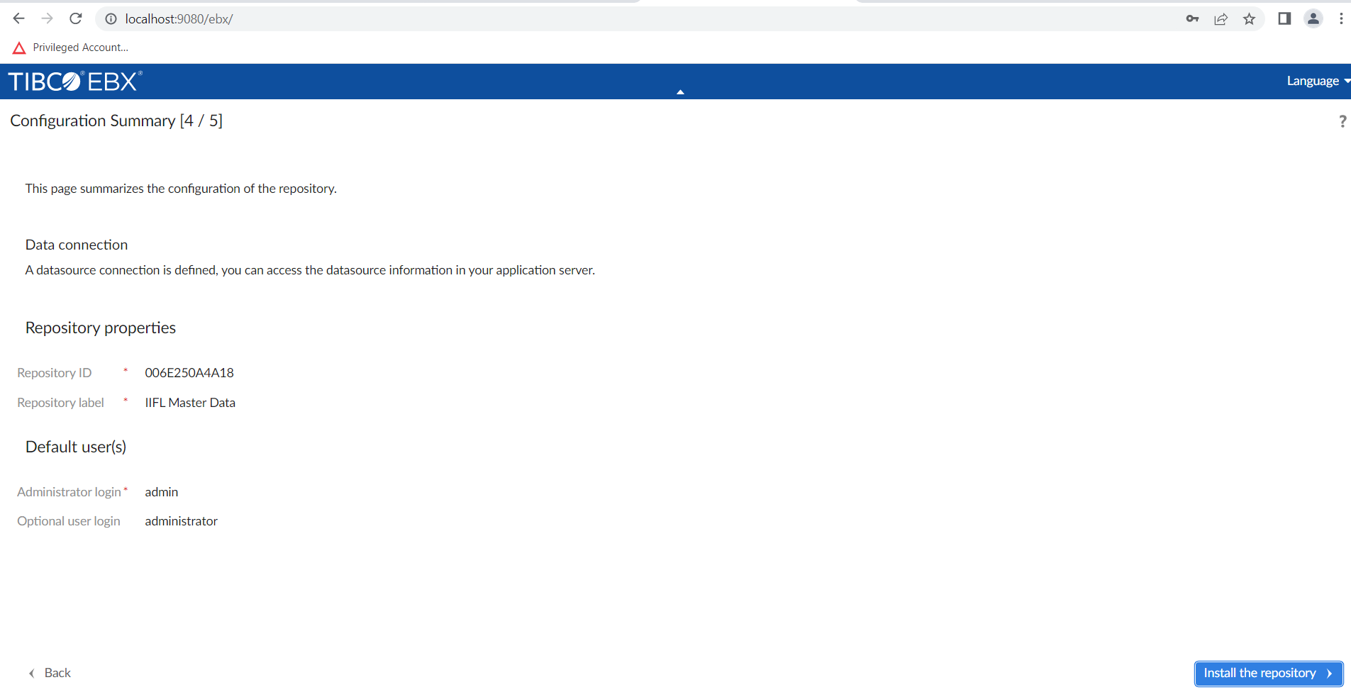

## EBX Login Screen

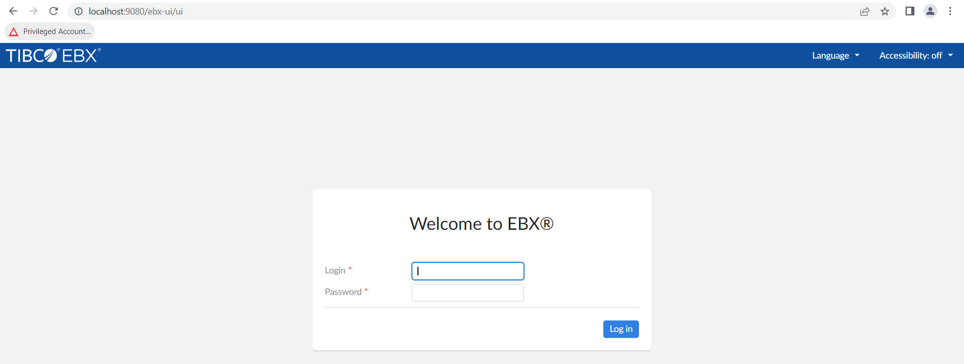

You can login now into the EBX using the credentials mentioned during the setup.

# TIBCO EBX Add-on Setup

TIBCO EBX add-on comes as a war file and we just need to deploy it inside the webapps folder of the ebxServer folder we created above.

Once the war files are placed in the webapps folder we need to restart the server.

But before using the war files we need to repackage them with the third parties’ libraries. This is a onetime process we need to do when we download the war files from the TIBCO delivery site.

## Packaging Third Parties

Prerequisites Before completing the numbered steps below, please complete the following:

* Download and extract the contents of the add-on bundle ZIP file to an accessible location. In this example we extracted to: C:\Users\Tibco\Downloads\TIB_ebx-addon_5.6.0
* Ensure the Java 1.8 JDK is installed and properly included in your PATH environment variable.
* Check that you have Apache Ant version 1.8 or newer installed.

**Procedure**

* Open a terminal and change to the directory where you extracted the add-on bundle.
* To run the script, execute the following command: ant -f script/ebxRepackageWithLGPL.xml
* When prompted, enter the location where you extracted the add-on bundle ZIP file. In our case it is C:\Users\Tibco\Downloads\TIB_ebx-addon_5.6.0
* To check if packaging is done properly run the command

ant -f script/ebxRepackageWithLGPL.xml check

